**Steps for Software setup (once):**

1. Download all procedures and needed files from the following Github repository <https://github.com/drius-22/chiron_reduc_pipeline>.

I suggest using GIT to download the files. First, install GIT in your computer, open the command prompt, navigate to the directory where the files will get place and clone the repository using the git clone command.

E.g. C:\users > git clone <https://github.com/drius-22/chiron_reduc_pipeline>

If successful, the following message will show “> Unpacking objects: 100% (10/10), done”

1. Install Python in your computer. IDL allows for integration with python scripts through the python bridge. The software uses python scripts to get rid of cosmic rays when more than three exposures are given.

Please follow the instruction in <https://www.l3harrisgeospatial.com/docs/python.html>. Once python is installed, we suggest using Pip as a package manager. Pip is installed by default with python for any python version greater than 3.4. To verify pip is installed, run the following commands in the cmd.

C:\> py -m pip –version

If successful, the following message should be printed:

pip X.Y.Z from ...\site-packages\pip (python X.Y)

Use pip to install the Numpy and the Astropy libraries by simply typing the following commands.

C:\> pip install numpy

C:\> pip install astropy

1. Launch the IDL Workbench and hit “Browse” for a new Workspace. Select the folder that contains “chiron_reduc_pipeline”, this new folder was downloaded from Github.
2. Add Projects to the present workspace by click in File -> New Project. Toggle the option “Create the new project from an existing directory”. Browse in your local file system for the folder “chiron_procedures” and select it. Fill the name field as you wish, verify the option “Update IDL path when project is opened or closed” is selected and hit the Finish button. Repeat the steps for the folder “utils” and “chiron”.
3. 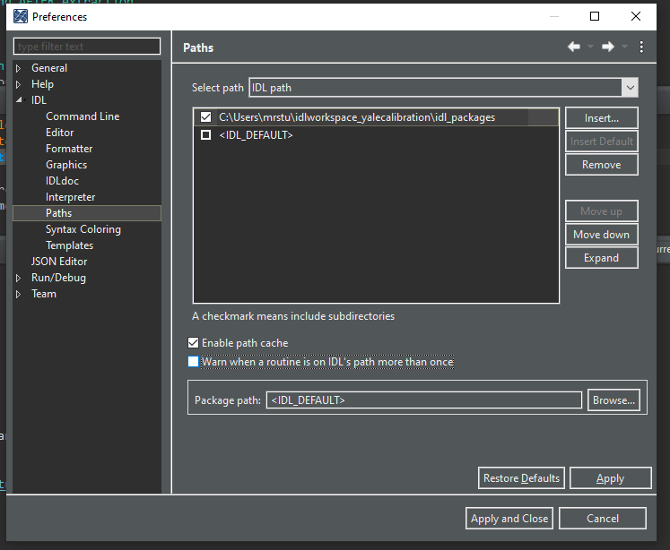Set up the paths of the libraries to be used along with the software. All libraries used are included in the Github repository within the folder “idl_packages”. To set up the library paths, select the “Window” option in the top bar of the workbench, select “Preferences” and navigate to the ‘Paths’ option in the ‘IDL’ tab. Finally, click ‘Insert’ and select the ‘idl_packages’ folder. The illustration shows a successful path setup. Unselect any other path, if any.
4. Create a new text file with the name ‘ctio.par’ one directory up to the .git folder. This is to prevent git updating this file. Copy/paste the content of the file ‘’ech.par” present in the “chiron_procedures” folder into ‘ctio.par’.
5. Open the file ‘ctio.par’ and change the variable ‘rootdir’ to point to the ‘chiron’ folder. The ‘chiron’ folder is also part of the files downloaded from the Github Repository. Note the coma after the path and the semicolon should not be removed.

E.g. rootdir: 'C:\users\chiron_reduc_pipeline\chiron\', ; root directory. All other paths are relative to rootdir

1. Open the procedure “sorting_hat.pro”, compile and run it using the button in the workbench. A message like the the one bellow will be printed.

******************************************************

You must be running things from a different directory.

Your current working directory is:

C:\users

ctparfn has not set.

Either changed your working directory, or modify the case

statement above this line.

******************************************************

The fourth line is your current directory, copy this path. Open the ‘sorting_hat.pro’ procedure in the workbench again and add this path to the CASE statement approximately in line 61. The CASE statement sets the variables ‘ctparfn’ to point to the ‘ctio.par’ file. (Note this file is among the files within the ‘chiron_procedures’ folder)

E.g. 'C:\users’: ctparfn = 'C:\users\chiron_reduc_pipeline\chiron_procedures\ctio.par'

**Steps for Reduction**

1. Create a folder with the name YYMMDD for the night to be extracted in the directory mir7\ E.g. ...\chiron\raw\mir7\210818 for the night of February 18th of 2021.
2. Gather all raw files including calibration files and place them in the directory created in step 1. (Notice the raw files received from Chiron tend to be placed in two different folders and have the prefix ‘chiYYMMDD’)
3. If any files other than the raw files with the prefix chiYYMMDD are in the directory, move them to a different folder.
4. If the raw files have names that do not follow this notation chiYYMMDD.XXX where ‘XXX’ is the observation number of a given night, *run the script ‘rename_chiron_notation.py’.
5. Set the environment variable ‘CHIRON_PATH’ in the current IDL session to the absolute path where the directory chiron/ was placed.

E.g . IDL> SETENV, ‘CHIRON_PATH=C:\users\mrstu\chiron’ (note the slash at the end of the directory is not included)

1. Create the .log file of the night of interest by calling the procedure logmaker.pro.

E.g . IDL> logmaker, ‘210128’, date=’210128’, /nofoc

(Notice this creates an ascii file (… chiron\tous\mir7\logsheets\2021\210208.log ) with information about all raw existing files in ...\chiron\raw\mir7\210818 \chi*.fits )

1. Open the file ‘ctio.par’ and change the value of the initial variables as desired.
2. Change the variables preferences for the reduction procedure itself by opening the file allreduce.pro and setting the variables. (Note the procedure allreduce.pro is being used for now, however there are other procedure that serve a main script.)
3. Run the extraction for a given night by calling the procedure allreduce.pro

E.g. IDL> allreduce, ‘210118’

**Additional setups:**

To install GIT:

To run script ‘rename_chiron_notation.py’: